A
CAPSTONE (Major) Project Report
on
<Name of the Project>

at
<Company Name>



Submitted by
<Name of the Student>
Registration Number – 17MCA_____

Guided by
<Name of the External Guide/s> <Name of the Internal Guide>
<Designation with Company Name> <Designation>
(External Guide) (Internal Guide)

Submitted in partial fulfillment of the requirement for
the degree of
“Master of Computer Applications”

Submitted to
School of Computing Science and Engineering
VIT Bhopal University
Bhopal (MP) – 466 114

<Month> 2019

Dear All,
All necessary information has already been sent to you in previous mails.
Note:
- Hard Binding with Blue shed leather cover.
- We are sending you the format of cover page
- All the red font content must be replaced by the specific information
- Keeps Side Strip having Project Name in cover page (IN COMPULSORY)
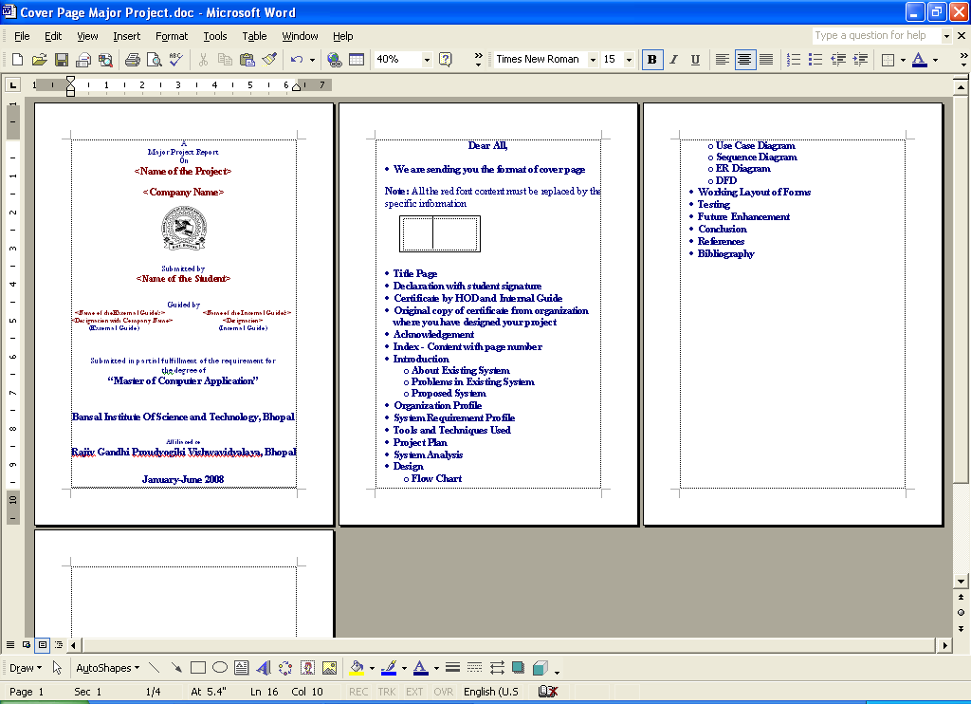
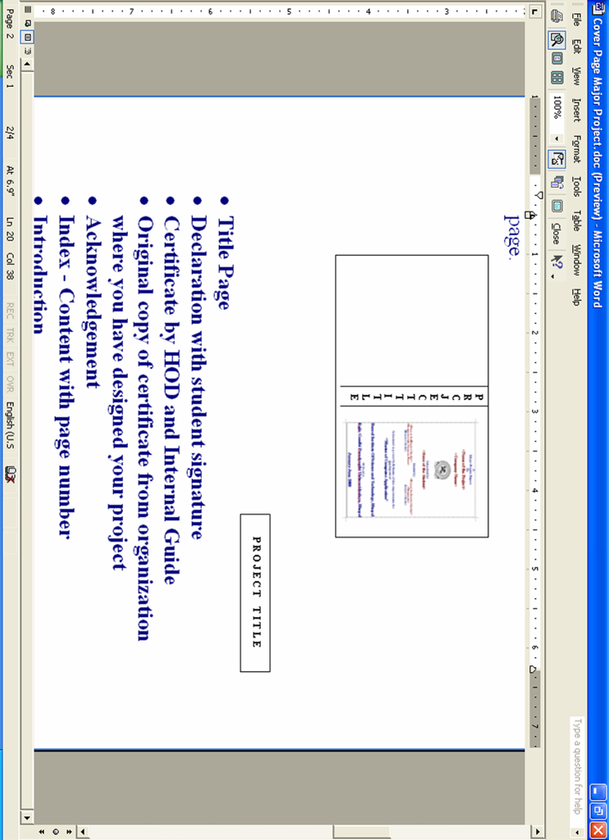
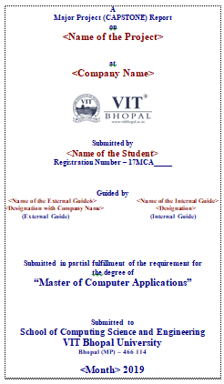

Sequence of Topics you have to cover-

- Title Page
- Self-Declaration of Student with student signature
- University Declaration [Dean Sign (Left Side) / Internal Guide Sign (Right Side)]
- Original/Color Scan copy of certificate from organization where you have completed your project
- Acknowledgement
- Table of Content (with page number)
- Introduction
  - About Existing System
  - Problems in Existing System
  - Proposed System
- Organization Profile
- System Requirement Profile
1. Software Requirement Specification
2. Hardware Requirement Specification
- Tools and Techniques Used
- Project Plan
- System Analysis
- Design
  - Flow Chart / Use Case Diagram / Sequence Diagram
  - ER Diagram
  - DFD
- Working Layout of Forms
- Reports
- Testing
- Future Enhancement
- Conclusion
- References / Bibliography
Project report size and font size and paragraph setting and presentation is considered for project - evaluation

- Your report will be rejected if you are not following the above instructions, binding color, patter, sequence, details etc…..
- Also SYNOPSIS is required to be added at the end of the report.
- We will send you dates and schedules of practical examination and also keep in touch with your Internal Guide.
- You have to also design the presentation snippet.
- Be Ready (Tentative), for I Review by 6 February, II Review by 18 March and T E Exams can be held any date and time after 22 April 2019.

Submit your project synopsis on or before 25 January 2019.

Synopsis Contents

- Front Page
- Color scanned print of your offer letter
- Company Profile
- Use of your project in real life/live project.
- Your Responsibilities in project.
- Technologies Used
- Proposed Project Plan
- Introduction ( About Project )

Project title (theme), work area, front end / back-end tools, various testing analyzing tools and utility, name of organization or company, duration, client to which you are attached for your project, module name, different platform and much more about you and your work.

The SAMPLE of other pages are attached for your perusal.

VIT BHOPAL UNIVERSITY, M P - 466114

SCHOOL OF COMPUTING SCIENCE AND ENGINEERING

CANDIDATE’S DECLARATION

I hereby declare that the Dissertation entitled “Title of Project" is my own work conducted under the supervision of Guide/Co-Guide Name, Designation, Name of School at VIT University, Bhopal.

I further declare that to the best of my knowledge this report does not contain any part of work that has been submitted for the award of any degree either in this university or in other university / Deemed University without proper citation.

(Name of Candidate)
(Registration No. )

This is to certify that the above statement made by the candidate is correct to the best of my knowledge.

Date:_______________

Guide Name

Designation

VIT UNIVERSITY BHOPAL, M P – 466114
SCHOOL OF COMPUTING SCIENCE AND ENGINEERING
CERTIFICATE

This is to certify that the work embodied in this Capstone Project Report entitled “……………………………………………………………” has been satisfactorily completed by Ms. /Mr. ……….......Registration No…………………in the School Computing Science and Engineering of ………………………..at VIT University, Bhopal. This work is a bonafide piece of work, carried out under my/our guidance in the School of…………………………. for the partial fulfilment of the degree of Bachelor of Technology.

Name of Guide
Designation

Forwarded by Approved by

Name of Program Chair Name of Dean
Program Chair Professor & Dean

Acknowledgement

Executive Summary

Note – It should contain a brief summary of the project and must contain the context/relevance of the problem at hand, a description of what was done and a gist of the significant observations/results. This should not exceed one page and should usually be of one paragraph.

List of Figures
Figure No. | Caption / Title | Page No.
2.1 | Schematic representation of a Network layers
…
3.2 | Time versus Speed

List of Tables
Table No. | Caption / Title | Page No.
2.1 | Database for product 1
. . .
3.2 | Database for product 2

List of Symbols &Abbreviations

A Ampere
ARM Association Rule Mining
DIC Dynamic Item-Set Counting
DM Data Mining
DHP Direct Hashing and Pruning

Note: All Abbreviations and symbols that appear in the report should be listed alphabetically. First give all roman symbols, then Greek symbols. Order: ASCII ordering, to the extent possible. Subscripts and superscripts should be listed separately if these are not an intrinsic part of the variable name.

Table of Contents

Title Page i
Self-Declaration of Student with student signature ii
University Declaration [Dean Sign (Left Side) / Internal iii
Guide Sign (Right Side)]
Original/Color Scan copy of certificate from organization iv
where you have completed your project
Acknowledgement v
Executive Summary vi
List of Figures vii
List of Tables viii
List of Symbols & Abbreviations ix

Contents Page No.

- INTRODUCTION
  - Heading1
  - Heading2
    - Sub heading1
    - Sub heading2

- LITERATURE REVIEW

- CHAPTERS AS PER DISSERTATION REQUIREMENT(OPTIONAL)

OTHER Details as mentioned above

Note: Number of Chapters may vary as per the requirement of Dissertation.
General guidelines to write the report.

TEXT REPORTS
It is mandatory to use plain A4 sized sheets, 70 to 80 gsm (16 to 20 pounds), and smooth finish - the type of paper that is used for good photocopying. The recommended margins are 25 mm (1 inch) for top, bottom, right and left with an extra 13 mm (0.5 inch) for binding on the left and the font size should be 12 with Times New Roman. Spacing between two lines should be 1.5. Other than page numbers, nothing should be included in these margins. The SI system of units should be used as far as possible. If non-SI units are the norm in the field, an addendum to the nomenclature must be given, identifying these units and giving conversion factors for translation to the SI units.

PAGE LIMITS
The total number of pages in the report, including figures, tables (but excluding the preliminary pages, references and appendices) should not exceed than 100 (Caution: These are upper limits. Avoid writing a report which is artificially fattened. Do not waste pages. Use space optimally).

Additional material (e.g. derivations, data sheets, of ICs, bills of materials, computer code listings etc.), which may be placed as appendices. These will not count in the total page count as per the specified page limits. Such matter can be placed only in the guide's copy provided this arrangement is approved by the guide, else these appendices should appear in all the copies.

Final report should be spiral bounded with white transparent sheets at the top.

MAIN PAGES
It is mandatory that the report be divided into chapters each of which may be structured into 2sections (1.1, 1.2) and sub-sections (1.2.1, 1.2.2). Each section heading should be in title case and subsection headings should be in sentence case and Chapter heading should be upper case. Do not exceed this level of sectioning. The sections and sub-sections must carry titles. If possible, try and use different fonts for section titles and sub-section titles. Each chapter should commence with a chapter number and title. The text should begin on the same page with 2 blank lines between the last line of the chapter title and the first line of the text material. Keep 1 blank line between the chapter number and the title. Adjust the chapter number and the title to fall in the center of the page and use bold, upper case fonts. The appendices, if any, may be numbered in upper case, Roman numerals (I, II etc.).

All pages, including figures and tables, should be numbered; the page numbers should appear at the bottom, right corner, except for the first page of a chapter, where these should appear at centre of the bottom of the page. The actual page numbering will commence from the first page of chapter 1.

Figures should be numbered sequentially with respect to each chapter. For instance, Fig. 3.2 will be the second figure of the third chapter. A similar numbering style should be adopted for tables. Figure should be captioned at the bottom in sentence case and tables should be captioned at Top in sentence case.

Figures and tables should be complete in all respects (legends, number, caption/title, reference (if any), coordinate labels with units). Experimental data should typically be represented by centered symbols, while theoretical data by continuous curves in figures. A figure should not be smaller than what will fit into half a page (i.e. the drawing itself + a 25 mm blank band surrounding it on all sides; space occupied by the caption/title is not included in this). The caption and number for figures should be placed at the bottom of the figure, while those for tables at the top.

Figures and tables should appear as close as possible to their first occurrence mentioned in the running text of the chapter these belong to. These must appear after the first mention and not before. Each figure / table should be on a separate page by itself.

Photographs should be treated as being equivalent to figures, with the caption being placed at the bottom of the photograph. Photocopies of photographs are not acceptable.

All equations should be numbered in a similar manner as the figures and tables. For example, equation 3.4 will be the fourth equation in Chapter 3. Equations should be written using equation writer of MS Office.

All symbols should be explained the first time these appear in the text.

When dealing with numbers use only the appropriate/correct number of digits. It is ridiculous to mention values of rates to the sixth decimal place when your measurements cannot go beyond, say, the third place.

When displaying computer code listings (usually in an appendix) ensure that these contain appropriate comment statements so that the code can be understood easily. It is always desirable to have a high degree of similarity between the variables names / symbols that you have used in the report and those which appear in the code.

ORDER OF THE REPORT IN SOFT AND HARD BINDING
The material should be placed and bound in the following order:
Top Sheet of transparent plastic
Order should be as per table of contents
Back cover (blank sheet)
(Consistent tense should be maintained in the report. Do not keep flipping between past and present tense. It has been the norm to use the passive voice ("was done") in technical writing. However, the active voice ("we did") is increasingly being accepted. Guide's consent should be obtained if the student wished to use active voice in his/her dissertation Pay attention to detail and accuracy. Be clear, but concise.

Make a sincere effort to weed out typographical errors. These mistakes will cost the students marks and may even earn him/her re-submission. If one has become tired of reading the report over and over again and suspect that this fatigue will cause him/her overlook typos and grammatical mistakes the student can get a friend to help out (perhaps similar help can be provided in reciprocation).

STRUCTURE
It is recommended that the contents of the report be structured into the categories/chapters described below. One may adopt a different way of organizing the material with the consent of the guide. There is a rough correspondence between the expectations outlined above for the different types of documents and the structure given below. However, the emphasis on the various aspects is different for each type of report.

Chapter-wise contents
Chapter 1: Introduction:
• Motivation
- Introduction (General Theory related to topic)
- Objective
- Brief Methodology (Preferably Bullet points)

Chapter 2: Literature Survey
• Should be as exhaustive as possible
• Primarily, one should discuss previous studiesand should write as per the format given below and it should be specifically pertain to the problem/topic at hand.
[1] Mahor et. al. (2010) has discussed about -----------------------------------( It should have the summary of the paper)
• Attempt to minimize referring to work which is indirectly related to the topic. Avoid making forced connections and do not try to cram in irrelevant references.
• The last part of this section must contain a brief mention of the gaps in the literature and a justification for undertaking the current project.
Note :
• A detailed report of previous studies, if necessary (Cite references properly at appropriate locations). Attempt to understand the material that is incorporated from various references. In a seminar, such a review will form the major portion of the main material.
• Do not restrict the references to the literature survey chapter only.
• Do not copy word for word from published literature.
• Ensure that sufficient details are provided for anyone to reproduce the work. •
Do not be too general. Avoid writing essays on historical developments.

Chapter 3 onwards –Main Material related to project can be presented the no. of chapters can be decided with due discussion with Guide.

Second last Chapter :Results&Discussion
• If there are too many aspects to be covered then organize them in a logical manner.
Last chapter : Conclusions
• State these clearly, in point-wise form if necessary, with respect to the original objective.
• Do not disguise "descriptions" of specific aspects, covered in the work as conclusions. For instance,"a correlation has been developed for estimation of heat transfer coefficients for annular flow..." is NOT a conclusion whereas "the heat transfer coefficient in annular flow does not depend on the wall material" is a valid conclusion.
Use annexure to describe anything that breaks the regular flow of the report such as, sample calculations, estimates of properties, numerical details etc.

APPENDIX-I

Title of Appendix

